Amanda Tam
TUL560
Dr. Viv Grigg
Summer 2014

Project 3.1: Microfinance Community Learning Experience

Introduction
As part of the Theology of Community Economics course this semester, I had the privilege of interning with Mission Ministries Philippines (MMP), my MATUL host organization here in the Philippines. MMP is a non-profit Christian ministry organization that focuses on planting churches in the poorest communities in Metro Manila; they emphasize that their ministry is holistic and addresses not only people’s spiritual needs, but also the very important physical ones too as their primary demographic are marginalized individuals who lack many basic resources and opportunities. Through this community engagement, I was able to learn about the beauty and challenges of micro finance up close and personal. I thought that it would be valuable to intern with MMP for this internship in order to obtain a better understanding of the ins and outs of a small grassroots organization as well as have the chance to see how MMP integrates microfinance into its holistic ministry. I was able to engage in this internship with my classmate, Erika, and we were both under the supervision of the primary microfinance loan officer for MMP, Kuya Mc Lloyd.

In Metro Manila, poor individuals will often lend from loan sharks known as 5/6 lenders. They are called “5/6 lenders” due to the fact that the interest is an astronomical 20% of the original loan amount. No credit or formal paperwork is needed and one can receive cash instantly, so they are often used, but borrowing from these lenders often causes people to go further in debt due to people’s inabilities to pay the exorbitant interest rate. Microfinance in the Philippines is a powerful tool in empowering people to develop small businesses and create a steady source of income to support their families; MF plays a unique role in development that creates sustainable and lasting effects.

Fundamentals of Micro Finance
I felt that Muhammad Yunus’ book, Banker to the Poor, which details the story of how he popularized micro finance when started the world renowned Grameen Bank, does an excellent job of describing how powerful microfinance is in poor communities. The idea of microfinance is so simple, yet so profound. The poor are unable to access credit from formal financial institutions such as banks due to their lack of collateral and are therefore denied the chance to lift themselves out of their trying situations. Yunus makes an important point of stating that the lack of such small amounts of money are causing so many people great misery (1999). The poor are being denied the same opportunities that middle and upper class individuals are offered by being denied loans, and thus micro finance restores the dignity of poor individuals by providing them with financial prospects as they work towards a better future.
Many women obtain loans to finance costs for their sari sari (variety) stores that are often frequented by people in the community

There are a variety of microfinance approaches including individual lending, village banking, and group lending and these depend on the community and cultural context the MF program is occurring in (Ledgerwood, 1999). It is common for MFIs in the Philippines to use a model similar to the Grameen model as the culture is very relational and the weekly meetings are very beneficial in encouraging saving and loan repayments and creates accountability among members of the group.

Principles and Practices of Christian Microfinance
As discussed in one of the lectures for the course, several of the principles of biblical community economics include creativity, productivity, and work (Grigg, 2014). Microfinance enables those in financial poverty the prospect of utilizing and engaging these principles and values in order to participate in employment that is lawful, provides ample capital, and is honoring to God. As God is a God of creativity and we are made in His image, the beauty of people’s creative abilities are allowed to flourish when they are provided with capital to develop small enterprises.

Peter Greer (2009) states,
“Sometimes a small discovery has the potential to change the world. Is it possible that microfinance has started a revolution to radically reshape the way we address severe poverty? We now see the poor not as objects of charity but as coparticipants in the vital work of economic development and global change” (p. 116).

I think that Greer’s quote is quite significant as it redefines how we view helping the poor, as it shifts away from the mindset of charity to empowerment. Microfinance offers the poor opportunities that they deserve as human beings. Greer (2009) stresses that it is a biblical mandate to care for the poor and it is important that the gospel be conveyed in economic programs such as microfinance. The church plays an important role in development globally and its imperative that it recognizes how integral economic issues are in the lives of people it seeks to reach out to.

A professor of mine, Attorney Raineer Chu, who is also one of the primary individuals involved in MMP’s microfinance program, has emphasized that poverty will be eliminated once everyone is evangelized and the church is able to embrace the authentic, biblical definition of community. He stresses that it is not about the church giving to the poor, or even about the rich giving more- it is about followers of Christ learning to share and to truly view others as brothers and sisters. Similarly, microfinance institutions and programs such as MMP’s provide the poor with opportunities to develop businesses and increase their livelihoods. This is more fruitful and beneficial than providing temporary handouts that are not beneficial long term.

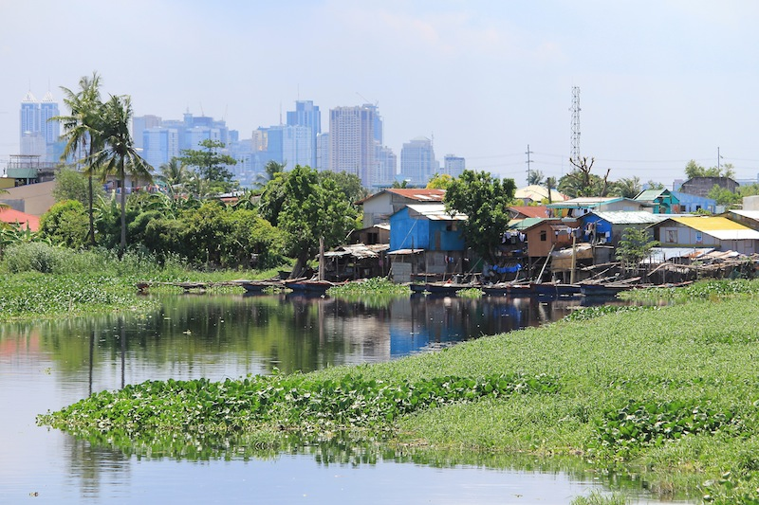
Techniques of Participation
On a weekly basis, Erika and I attended meetings of the two communities that Kuya Mc Lloyd is currently distributing loans in. One community known as “C6” was in Taguig and next to Laguna Lake. The other community “Towerville” was in Bulacan, a provincial area outside of Metro Manila.

Erika and I were able to help assist with the loan request process as we asked the women who were requesting loans for their information as we filled out loan request forms. The forms were rather basic and did not require too much information or calculation; questions included average income and profit of their small businesses, average household expenses, description of their small businesses, and contact information. We also were able to assist in leading some parts of the meetings such as giving brief messages related to biblical economics and praying for the group. In every internship meeting and outing, we were able to learn more about the challenges of micro finance, which will be expounded on subsequently.
The C6 community next to Laguna Lake, one of the communities that MMP works in and we were able to visit

Details of the MFI Structure
MMP’s loan cycles last 4 months (16 weeks) each, and each week there is a meeting with all of the people who currently have a loan with the organization. MMP uses a simple model for these meetings that can be briefly summed up in the “4 W’s.” These 4 W’s consist of Welcome, Worship, Word, and Work. “Welcome” is a brief introduction and greeting as everyone settles in to the meeting venue; “Worship” consists of a worship song or two in Tagalog or in English; “Word” consists of a brief message from the Bible that is given to the group related to economics; “Work” is the time when repayment loans are recollected from the women and/or money is distributed to the women who are receiving loans that they have been approved for.

MMP has specific guidelines for the venue that is selected for the weekly meetings during the 16-week cycle. Their venues need to be accessible for all fellowship members and staff, and also must be secure from heat, rain, and people with undesirable character traits as large sums of money are being distributed and collected; the location of the meeting should also have privacy and the owner of the venue should be comfortable with prayer and bible study occurring there.

Even more importantly, there are a multitude of criteria for borrowers of the micro finance loans. The borrowers must be between the ages of 18 through 60, and be physically and mentally able to work. The borrower must not have any loans with any other microfinance institutions (MFIs). MMP requires that the borrower currently own a small business, as they have stated that it is far too risky for a MF loan to be distributed if the individual does not currently have a business, as the percentage of small business startups that fail is extremely high. Kuya Mc Lloyd has stressed how important it is that the reputation of the borrower in the community must be good in order to determine if he or she has good character and will repay the loan as promised. The interest rate on the loans is 4% and these fees go towards the processing of the paperwork, the costs of transportation for the loan officer, and rent and maintenance of the MMP office headquarters.

Integration of Ministry
There is a very simple integration of Christian principles in MMP’s microfinance loan process. The microfinance loans are only offered in the communities that a church has been planted in or is currently being planted in so that there are already previous connections through the other members of the church planting team. As previously mentioned, the main portion of every weekly meeting involves some worship, scripture, and prayer. The relationships that the loan officer makes with the microfinance clients are also an important aspect of the ministry, as this is where the love of Christ can be demonstrated in word and deed. The clients are to be treated with respect and dignity, loved, and encouraged in the loan process.

Challenges
At one of the final microfinance meetings in the Towerville community in Bulacan, we noticed that the meeting was missing a few of the women who regularly attended. Kuya Mc Lloyd stated that this was due to the fact that some of the women had gone to a “release” for another microfinance organization. Although one of the policies of receiving a loan through MMP is that the individual receiving the loan cannot be involved in receiving loans with any other MFIs, he states that it continues to happen as people get a little too “loan happy,” but that this is something that is out of his control and he cannot prevent people from seeking out loans from other MFIs. Irregular attendance to the group meetings is detrimental to the loan process as money cannot be collected and loans are not being repaid for on time.

Screening of the MF clients is one of the primary challenges for MMP. Kuya Mc Lloyd says that it takes a great deal of time to get to know people and develop relationships with everyone before distributing loans. It was evident in both communities that Kuya Mc Lloyd was familiar with each of the women that had loans with MMP. Their interactions were not formal and distant, but cordial and familial. He knew every woman’s name, business, and background. He said that there is no other way to determine if someone has good or bad character aside from getting to know them in a personal manner. Microfinance clients do not go to a central bank, but the loan officers go directly to the people, and this is difficult due to the long commute and traveling conditions that are physically exhausting (most days, it took about 1.5-2 hours each way).

Suggestions for Improvement of the MFI
Just as Jesus sent the disciples out in pairs, I believe that it is important that the to be multiple loan officers going out into the field. Kuya Mc Lloyd is the only Microfinance Loan Officer for MMP to go out into the different communities to distribute loans, collect the return payments, and facilitate the weekly meetings. MMP is a small grassroots organization and MF loan officers need a sufficient training so it is easier said than done to send more individuals out into the field to distribute loans and collect payments; the majority of MMP’s team consist of those who are solely involved in church planting. Kuya Mc Lloyd has expressed that he would actually prefer to return to church planting instead of microfinance, but there is no one else to replace his current position.

As previously mentioned, transportation to these distant communities is very time-intensive as well as costly. I believe that having an individual from MMP who lived in or near the community would be beneficial in terms of helping residents of the community with the development of their small businesses. There would potentially be more accountability with someone who would be much more physically present. Trainings on budgeting, saving, and small business development and improvement could be offered to supplement the microfinance loans, but they need not be mandatory. We discussed with our supervisor about the dangers of pairing microfinance programs with the church and the potential negative consequences that could result from the church directly being involved in money matters and loan distribution.

Conclusion
I understand that Mission Ministries Philippines is a small grassroots organization, but I believe that there is so much more potential for the organization to further develop its micro finance program. Economic development is an important part of community transformation and microfinance helps contribute to the uplift of the impoverished.

This internship, or on-the-job-training (OJT) as they call it in the Philippines, was a significant learning experience for me as I was able to peer into the world of microfinance. Although it’s not a simple, one-size-fits-all-solution, microfinance is one step towards allowing the poor to have the dignity that they deserve and desire.

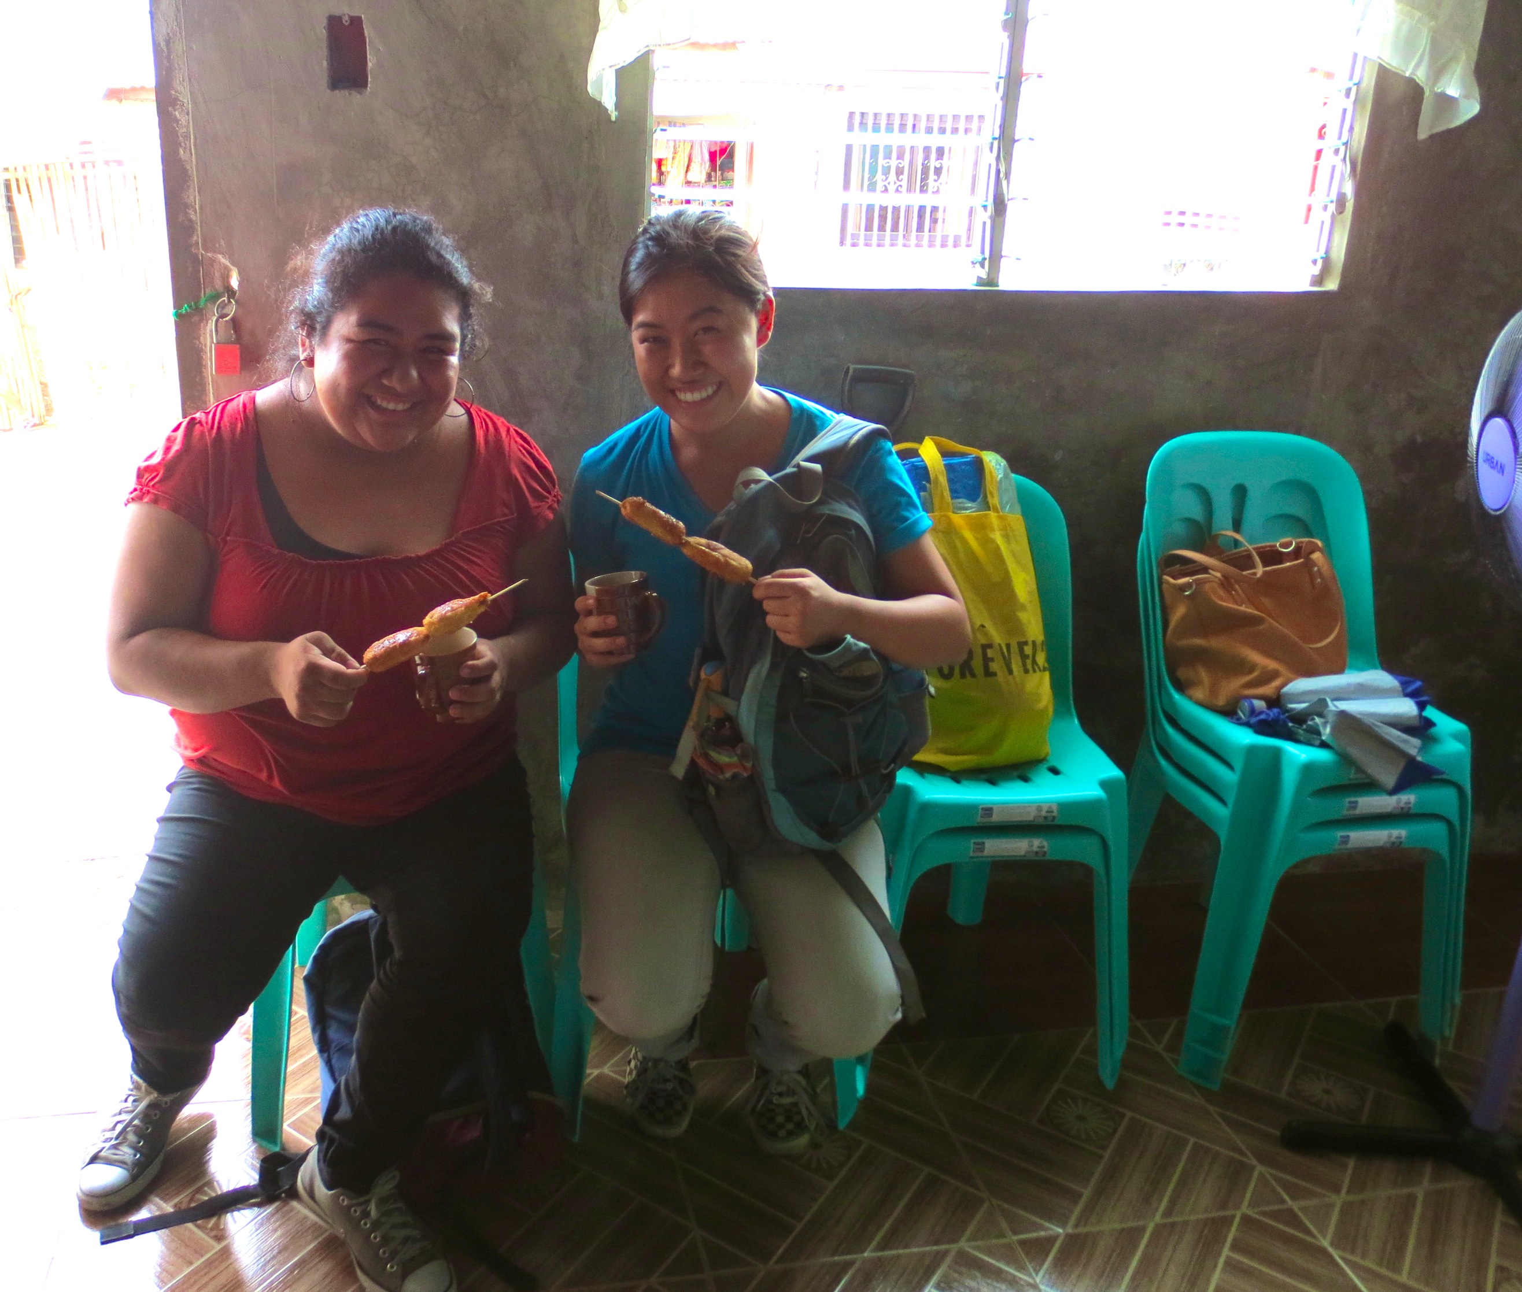

Erika and I partaking in meryenda (snack) at one of the MMP microfinance meetings in Towerville, Bulacan

References

Greer, P. and. Phil. Smith. (2009). The Poor Will Be Glad: Joining the Revolution to Lift the World Out of Poverty (Kindle ed.). Grand Rapids, MI: Zondervan. Pp. 56-128.

Ledgerwood, J. (1999). Products & Services. In Microfinance Handbook: An Institutional and Financial Perspective. Washington, The International Bank for Reconstruction and development/World Bank. Chapter 3. Pp. 63-91

Yunus, M. (1999). Banker to the Poor: Micro-Lending and the Battle Against World Poverty (Kindle ed.). New York: PublicAffairs. Pp. 1-292.

